 | Entry | Standard
Infant | Free | Free
 | Access to designated infant events throughout the year | Access to designated infant events throughout the year
Junior | Free | (50p per student Ks2)
 | Access to all Designated School Games Competitions | Access to all Designated School Games Competitions.  Access to District Athletics  Access to District Swimming  Financial support to Basildon District teams.
Primary | Free | (50p per student Ks2)
 | Access to all Designated School Games Competitions | Access to designated infant events throughout the year  Access to all Designated School Games Competitions.  Access to District Athletics  Access to District Swimming  Access to all Change 4 Life Festivals  Financial support to Basildon District teams.
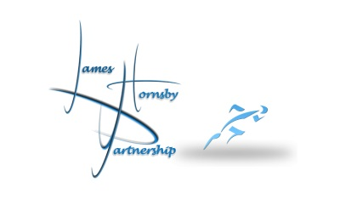
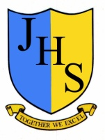
James Hornsby Partnership
Packages 2016-17

